EXPERIMENT:24

Create a Storage service using any Public Cloud Service Provider (Azure/GCP/AWS) and check the public accessibility of the stored file to demonstrate Storage as a Service.

Step 1: Create a Storage account.

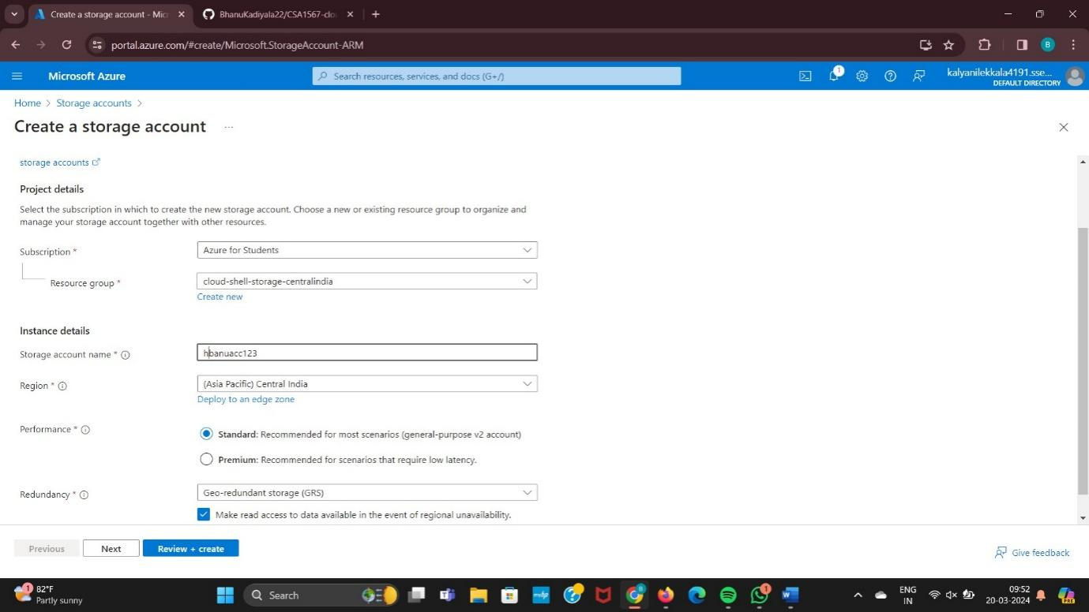

Step 2: Goto Advanced and Enter the details.

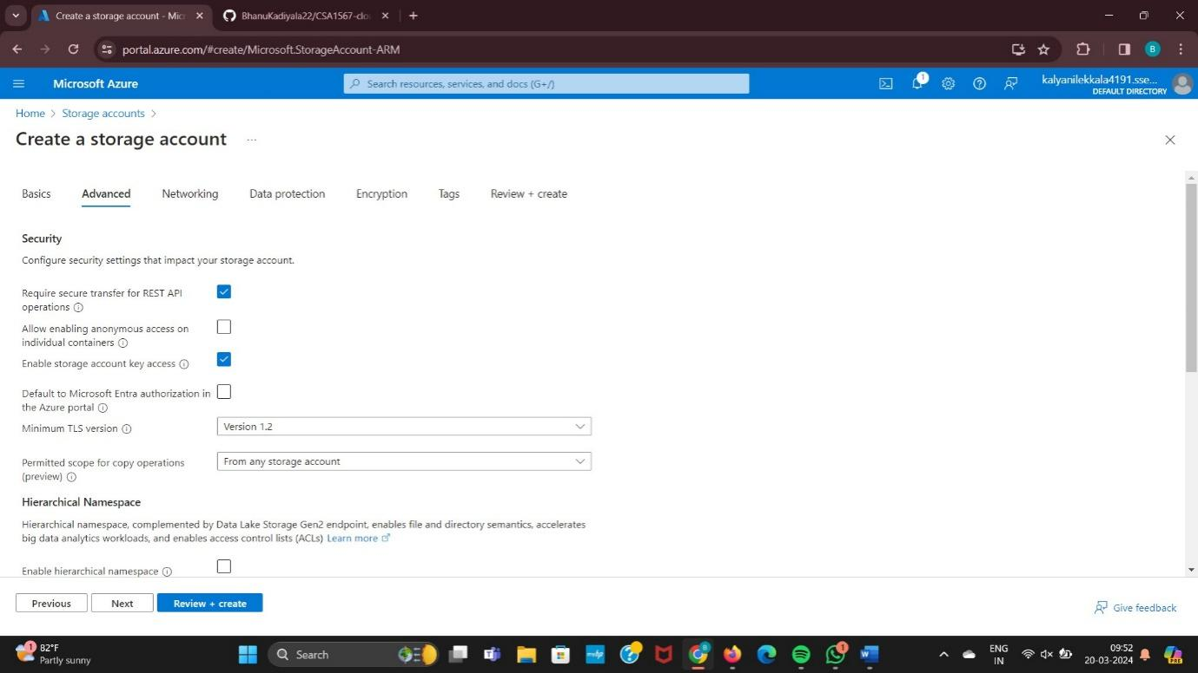

Step 3: Goto Networking and enter the details.

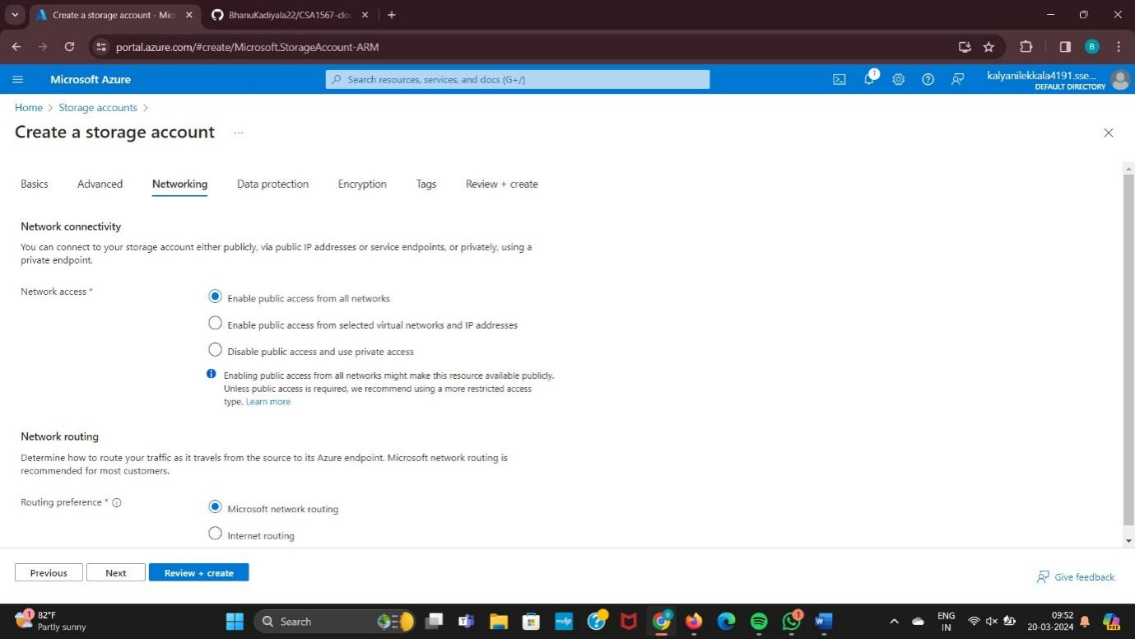

Step 4: Goto Data Protection and enter the details.

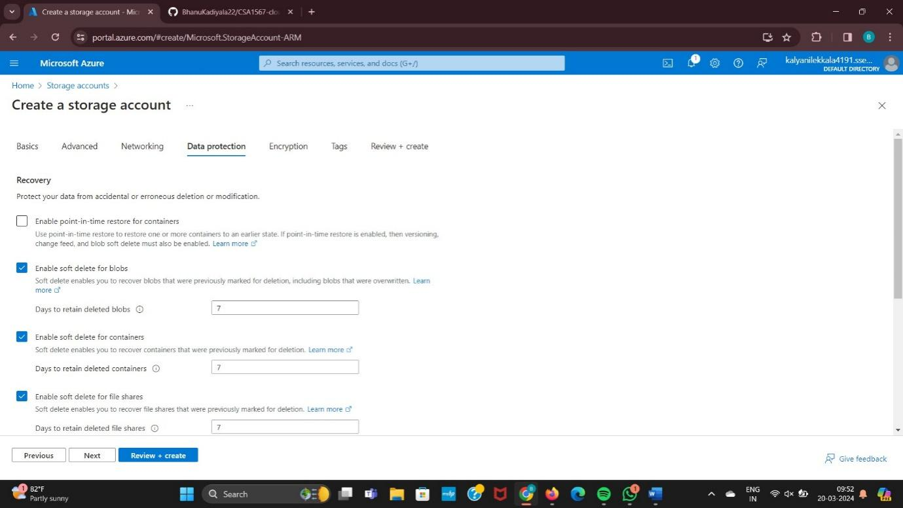

Step 5: Goto Encryption and enter details.

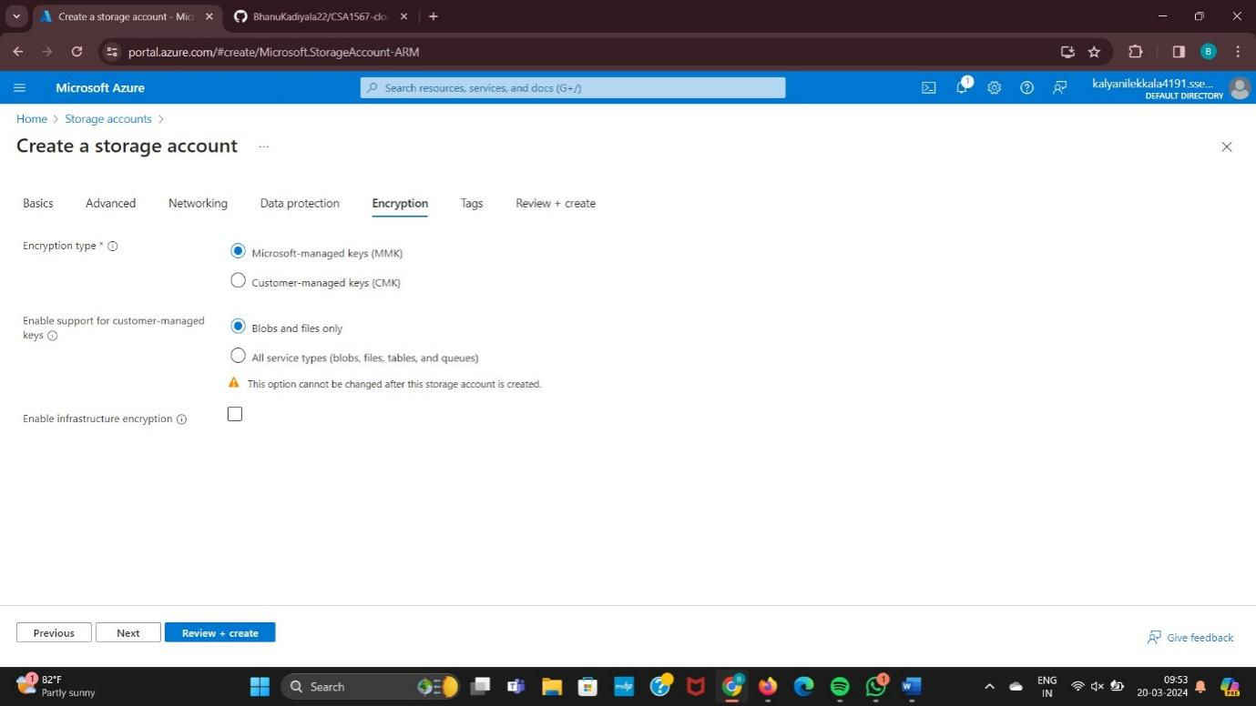

Step 6: Goto Tags and Enter details.

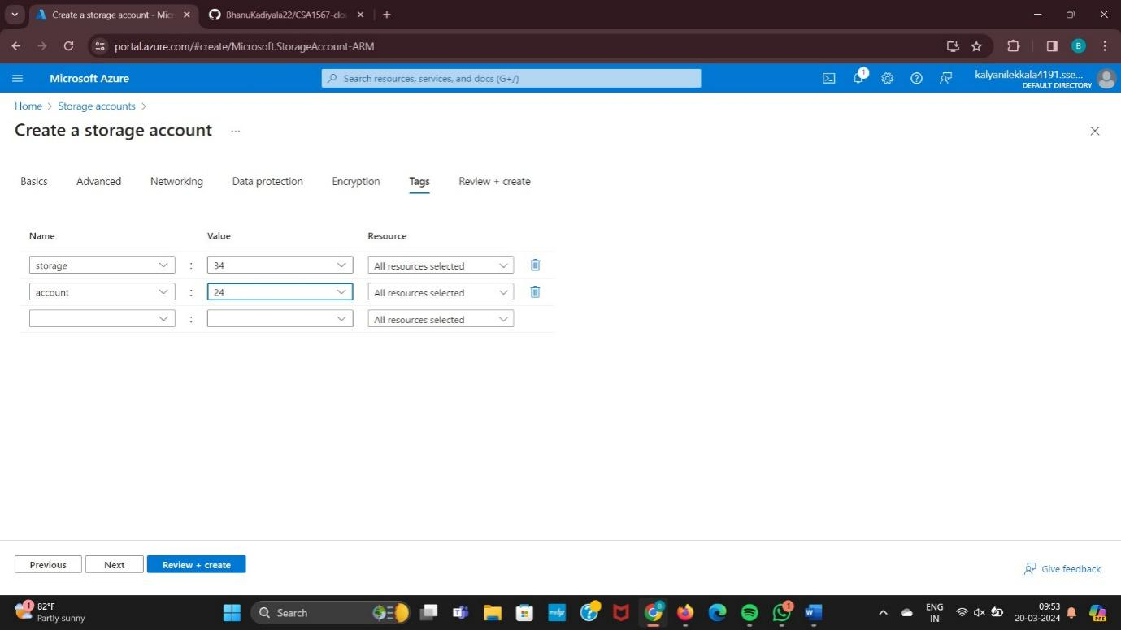

Step 7: enter Create Option.

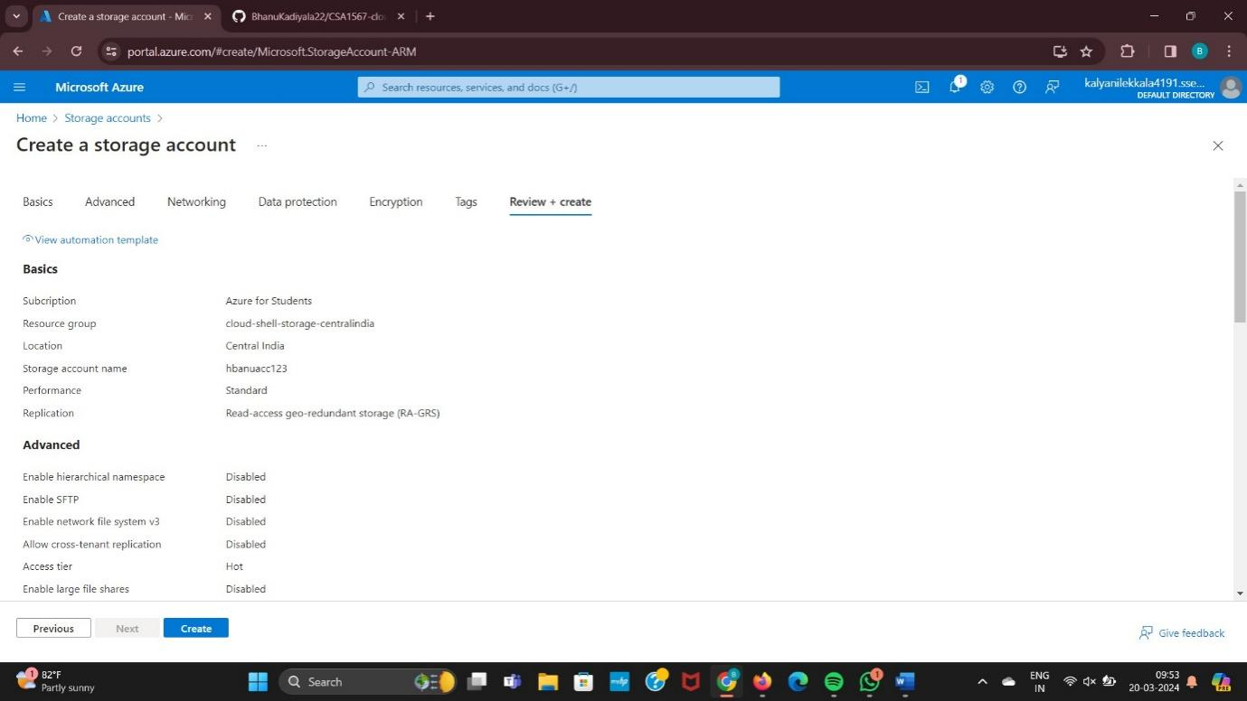

Step 8: Deployment is in Progress.

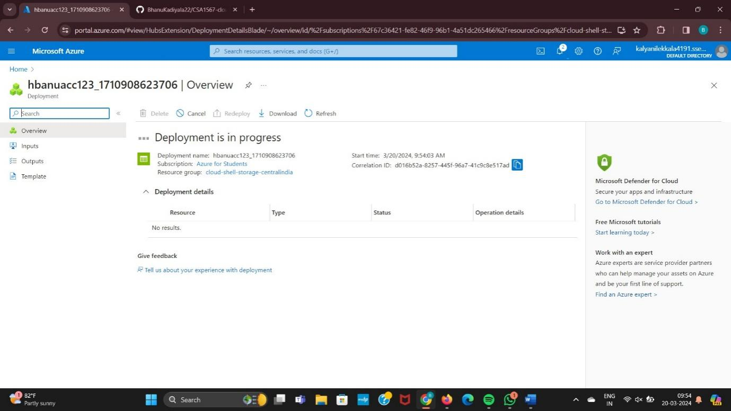

Step 9: Deployment is Completed.

